CYBERCRIMES IN THE SOCIETY IN CAMEROON ANALYSIS REPORT

INSTITUTIONAL IMPERSONATION
In 2025, Cameroon witnessed a massive increase in digital identity theft targeting the State. Fraudsters successfully created and operated thousands of fake accounts on platforms like Facebook and TikTok, impersonating government officials (Ministers, Directors) and public institutions (The Presidency, MINESUP). These accounts primarily serve as "bait" for recruitment scams and financial fraud, leading to a reported national loss of 1.027 billion FCFA in 2025.

Incident Analysis & Case Mechanics
The "Fake Institutional Account" crime follows a specific operational workflow:
- Platform Proliferation: Since January 2024, 8,499 fake accounts were identified by ANTIC.
- The Deception: Criminals use official logos, professional photography of high-ranking officials, and formal language to mimic official government portals.
- Targeting: Victims are typically young job seekers or entrepreneurs looking for government grants.
- Monetization (The Payload): Scammers demand "administrative fees" for fake civil service placements or "file processing" via Mobile Money. ANTIC currently processes roughly 200 judicial requisitions per day to investigate these specific transactions.

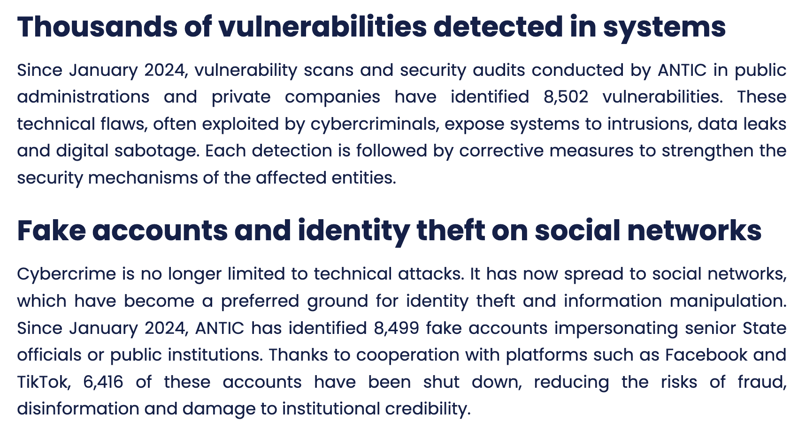
Screenshot from the Digital Business Africa website

Legal Classification (Law No. 2010/012)
Under the Cameroonian legal framework, this activity is not treated as a simple prank but as a serious felony.

Identity Theft (Section 60 & 61)
- The Violation: Usurping the identity of a natural person or a legal entity (the State).
- Legal Reasoning: Because the impersonated individuals are "Public Authorities," the crime is considered an attack on the State's integrity.
- Penalty: Up to 10 years imprisonment and fines reaching 50 million FCFA if it results in financial harm or damage to the official’s honor.

- Electronic Fraud and Phishing (Section 42)
- The Violation: Deceiving victims to obtain an undue economic benefit using a computer system.
- Legal Reasoning: The use of social media as a "mask" to facilitate theft changes the charge from "simple theft" to "Cyber-fraud," which carries harsher penalties due to the difficulty of tracing the perpetrator.
- Dissemination of False News (Section 78)
- The Violation: Publishing news that is likely to disturb public peace or peace of mind.
- Legal Reasoning: Fake recruitment notices cause public disorder and financial instability. Under Section 78, this is punishable by up to 2 years in prison and/or fines of 1 to 5 million FCFA.

Mitigation & Institutional Response
The State of Cameroon has intensified its counter-measures through:
- Direct Takedowns: ANTIC collaborated with Meta (Facebook) and ByteDance (TikTok) to shut down 6,416 fraudulent accounts in the last 18 months.
- Digital Forensics: The CIRT (Cyber Incident Response Team) now processes nearly 73 terabytes of data annually to authenticate digital evidence (like WhatsApp logs) for court proceedings.
- Verification: Official government sites are being moved to the .cm top-level domain to distinguish them from fraudulent commercial sites.

References
- Law No. 2010/012 of 21 December 2010: Relating to Cybersecurity and Cybercriminality in Cameroon. : https://ictpolicyafrica.org/fr/document/2xyan42talo#:~:text=1REPUBLIQUE%20DU%20CAMEROUN%20REPUBLIC,the%20Republic%20hereby%20enacts%20the
- ANTIC 2025 Annual Performance Report: Official statistics on fake accounts and judicial requisitions.
- Digital Business Africa (Jan 2026): "Cybersecurity in Cameroon: 200 judicial requisitions per day." : https://www.digitalbusiness.africa/en/cybersecurity-in-cameroon-in-2025-fake-accounts-hacking-vulnerabilities-200-judicial-requisitions-per-day-antics-alarming-figures/#:~:text=It%20has%20now%20spread%20to,State%20officials%20or%20public%20institutions.

- MINPOSTEL 2025 Policy Address: Statement by Minister Libom Li Likeng on national financial losses to digital fraud.

